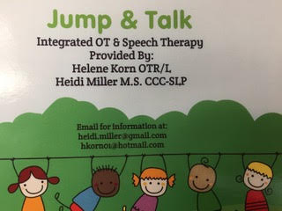

JUMP & TALK CO- TREATED THERAPY
Heidi Miller, SLP & Helene Korn, OT
integrated Speech & Occupational Therapy

Groups Available
- Jump and Talk Group
- Sensory feeding Group
Integrated OT and Speech therapy benefits include:

increased focus with inclusion of motor activities
Save time if your child benefits from both services
Save money (3+ children)
Increase performance
Social/ peer component, which is an additional motivator

Please inquire if you think your child could benefit. We will carefully form groups based on a number of factors.

Also Available… Co- treated INDIVIDAL sessions
(one child with both OT and SLP)

